SE SELF PERPARED NOTES
CH:1 TO SOFTWARE AND SOFTWARE ENGINEERING
1.Difference between process and product.
ANS:
1.Program:
- The use and need of computers is widespread in today’s world. The computer system is however incapable of working on its own and needs certain instructions to do anything. These instructions are provided to the computer system by a computer programmer. A collection of instructions meant to perform a specific task, written by a computer programmer is called a program.
2. Product:
- It is made only on the request of an enterprise. The team of developers undertakes the making of the product (called project). A software product is the finished project which was made after performing the various software development life cycle stages. After the completion of these stages the product comes into existence. It is then made in more numbers, for distribution. The software product is made to solve a specific problem.

2.Define software. List qualities of software.
ANS:
Software:
- A software is a set of instructions of different kinds of instructions or a program which is used to operate a computer system and related devices.
- It tells the computer devices what to do.
- It also includes the representation of audio, video or pictorial information.
The characteristics of software are:
- Cost efficient
- Easy to use
- User friendly
- Efficient
- Modifiable
- Modular
- Flexible
- Portable
- Proper documented
- Reliable
- Re-usable

3.What is software engineering. Explain the need of software engineering.
ANS:
Software engineering:
- Software engineering is a systematic approach to develop and maintain the software.
- A software engineering is a process of analysing the user’s needs and designing, constructing, testing the end user’s applications that will satisfy these needs through programming languages.

Needs of Software engineering:
- To help the developers to obtain high quality product.
- To develop a product in a proper manner.
- To provide a software product in a timely manner.
- To acquire the skills to develop a large program and also to be a better programmer.
- To provide a quality software.
- To finalize or to create a product at agreed cost.
- To develop a quality software which solves the complex problems.

4.Explain software engineering layered approach in detail.
ANS:
There are four different layers:
1.Quality
2.Process
3.Method
4.Tools
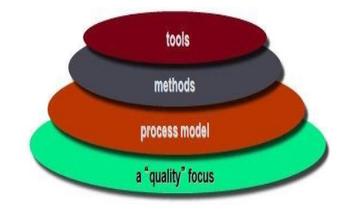
1.Quality
- The main focus of software engineering process is to develop a quality product.
- Quality of product refers to the characteristics that engineer specifies for their product.
- It also specifies that the final product or the output meets the functions of customer.

2.Process
- A process is the heart of software engineering layered approach.
- A process is an intermediate layer which combines the technology layers.
- A process is an execution or steps taken for developing a product.
3.Method
- The layer after process is called method.
- A method is prescription for how to execute the process and also how to build a software.
4.Tools
- Tools provide directed or undirected support to the process layers and method layers.
- A tool can be any software and hardware devices.

5.Explain Software process framework activities.
ANS:
- A process framework establishes the foundation for a complete software process by identifying a small number of framework activities that are applicable to all software projects, regardless of size or complexity.
- It also includes a set of umbrella activities across the entire software process.
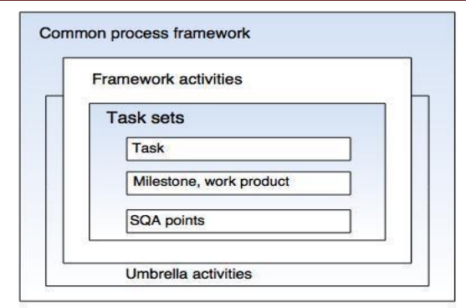

- These above described five activities can be used in any kind of software development:
1.Communication
- This activity involves heavy communication with others and customers stakeholders in order to gather requirements and other related activities.
2.Planning
- Here a plan to be followed will be created which will describe the technical tasks to be conducted, risks, requirement resources, etc.
3.Modelling
- A model will be created to better understand the requirements and design to achieve their requirements.
4.Construction
- Here the code will be generated and tested.
5.Deployment
- Once the product is created it will be released into the market for evaluation.
- Based on that evaluation the feedback will be given by the customer.

6.Explain software development life cycle.
ANS:
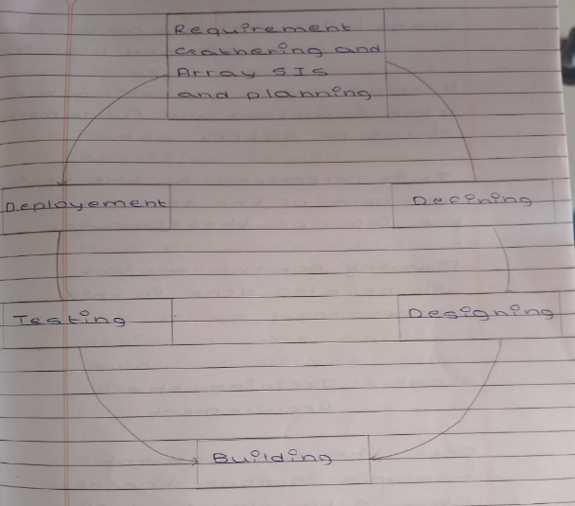
Stage 1: Requirements gathering and analysis
- A requirement gathering is the most important and fundamental stage of SDLC.
- It is performed by the senior members of the team with the input of the computer.
- Planning for the project will be also done in this stage.
Stage 2: Defining the requirement
- Once the requirement analysis is done the next step is to clearly define and document the product requirements and get the approval from the customer.
Stage 3: Designing the product architecture.
- Based on the requirement specified in SRS usually more than one design that approach for the product architecture is proposed and documented in design document specification.
Stage 4: Building or developing a product.
- In this stage of SDLC the actual development starts and product is built.
- The developers will follow all the coding guidelines.
- The languages used in this stage are Java, Python, C, C++, and etc.
Stage 5: Testing the product
- This stage is a subset of all the stages as in the model SDLC all the testing activities are mostly involved.
Stage 6: Deployment
- One the product is ready to be deployed it is formally released to the appropriate market.
- Based on the feedback the product will be launched into the market.

7.Expalin Waterfall model with neat sketch.
ANS:
- This model is also known as linear sequential model.
- In this model developers must complete each phase before the next phase begins.

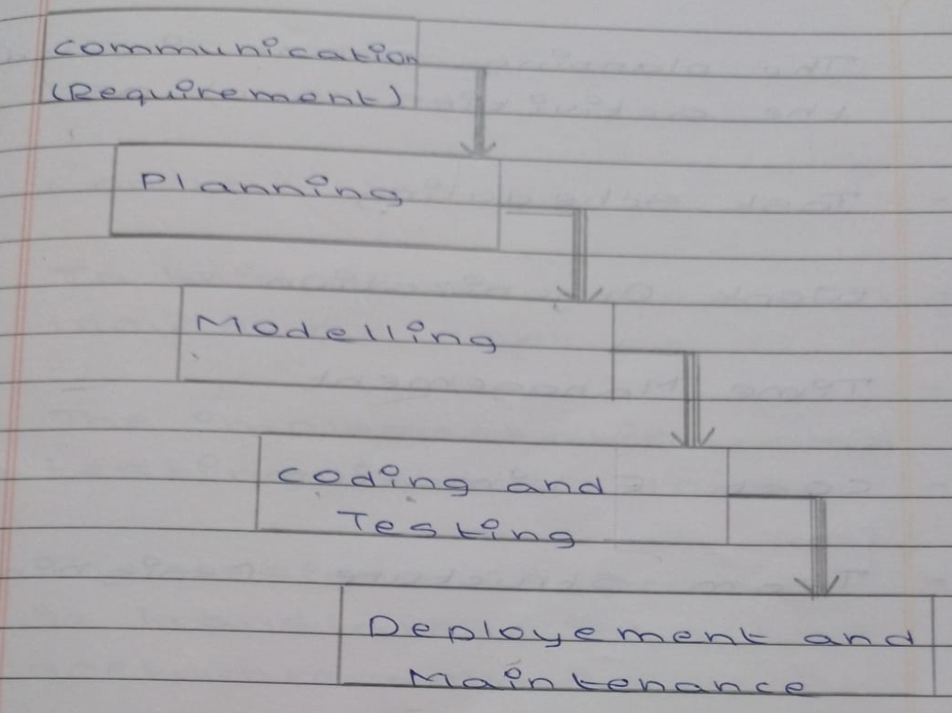
1.Communication
- Requirements are gathered.
- The problem is specified along with the desired services objectives.
- The requirement analysis would be done and the system’s specifications are produced.
2.Planning
- The planning phase includes the activities such as:

- Task scheduling
- Work organization
- Time management
- Cost estimation
- Team structure designing

3.Modelling
- At this stage software engineering is concern with:

- Software architecture
- Data structure
- Interface design
- Flow representation
4.Construction
- In this stage the coding would be done.
- The implementation and testing are also done.
- The designs of product will be translated into the software domain.
5.Deployment
- Once the product is created it will be released into the appropriate market for the evaluation.
- Based on the evaluation the feedback will be given by the customer.

Advantages:
- Easy to explain to the user.
- The activity and the stage are well defined.
- It is document driven.
Disadvantages:
- Difficult to define all the requirement at the beginning of project.
- Delays can occur in designing, coding and testing.
- Time consuming.

8.Expalin prototype model with neat sketch.
ANS:
- Prototype model is a working model that is functionally equivalent to the component of the product.
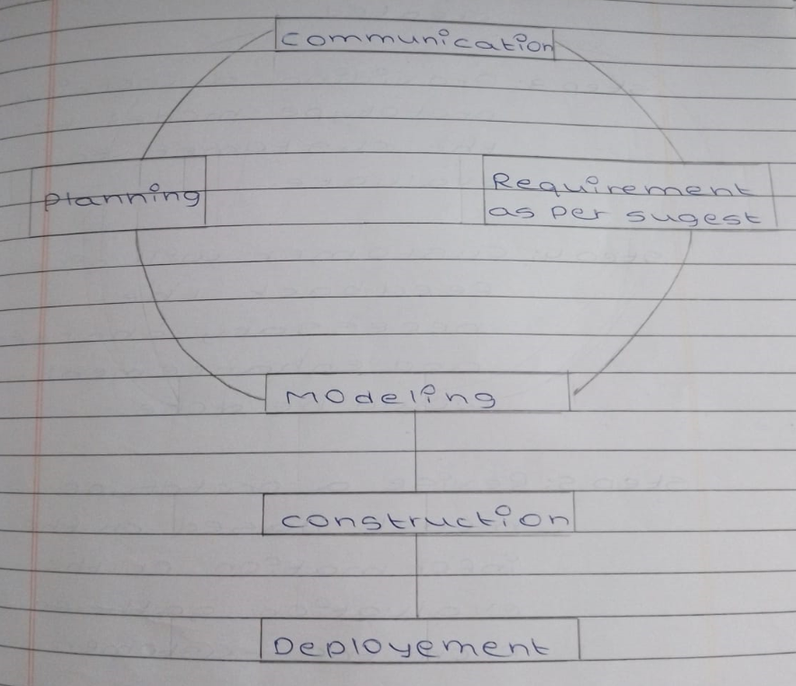
Step 1: Identifies user’s needs and requirements.
Step 2: Based on that a working prototype model is created.
Step 3: Providing a working prototype model to the customer to evaluate.
Step 4: Customer will give feedback the necessary charges and enhancement would be done.
Step 5: Revise a prototype model based on the information or the evaluation gathered from the customer.
Step 6: The actual development would start after getting approval from the customer for working prototype model.
Advantages:
- Provides a better system to the user.
- Errors will be detected earlier.
Disadvantages:
- It may increase the complexity of the system.
- It requires extensive involvement of the customer which is not always possible.

9.Explain Spiral model with neat sketch.
ANS:
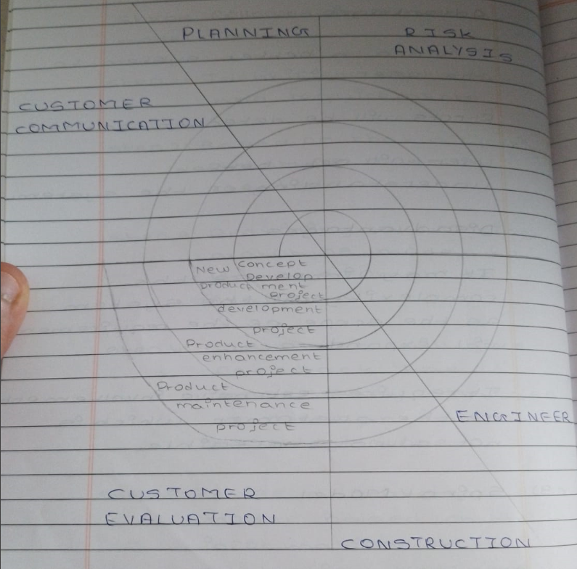
- The spiral model gives an efficient development of the incremental versions of software.
- A spiral model is divided into a number of framework activities and those activities is denoted by task regions:

1.Customer Communication

- In this task regions the customer communication is defined by collecting requirements.
- Analysis of requirement is also been defined in this task region.

2.Planning
- Here a plan to be followed will be created which will describe the technical tasks to be conducted, risks, requirement resources, etc.
3.Risk Analysis
- The task required to calculate the technical and management rsik are carried out.
4.Engineering
- In this task region the tasks required to built one or more representation of applications are carried out.
5.Construction and Release
- All the necessary tasks are required to construct, test, install the application are carried out.
6.Customer Evaluation
- Customer feedback is obtained and based on evaluation of them the task which are performed and implemented.
- In spiral model the software engineering team moves around the spiral in clockwise direction.

Advantages:
- Good for large and complex projects.
- Efficient risk handling.
Disadvantages:
- Expensive
- More complex than other process models.

10.Explain Incremental model with neat sketch.
ANS:
- In incremental build model is a method of software development, where the model is designed, implemented and tested incrementally until the product is finalised.
- It involves both development and maintenance. The product is defined as finished when it satisfies all its requirements.
- Incremental model is a process of software development where requirements are broken down into multiple standalone modules of software development cycle.
- We can analyse that at the initial stage, core product is developed. Then by adding customer requirement or new functionalities.
- In this model, the system is broken down into several modules which can be incrementally implemented and delivered.
- It involves that it is also referred to as successive version of waterfall model using incremental modules.

Advantages:
- This model is less costly compared to others.
- A customer can respond to each building.
- Errors are easy to be identified.
Disadvantages:
- Sometimes it is difficult to subdivide problems into functional unit.
- Model can be used for very large problems.
- It needs good planning and design.

11.Explain RAD model with neat sketch.
ANS:
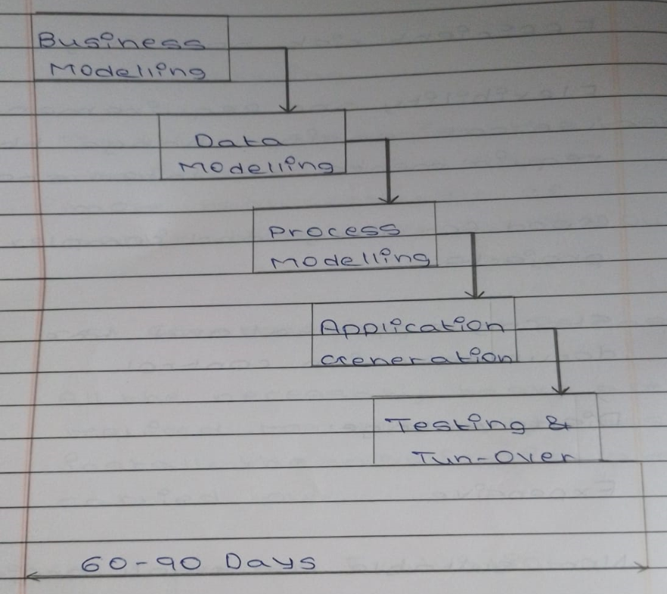
1.Business Modelling
- The information flow among the business function is modelled in a way that answers following questions:

(1) What information drives the business process?
(2) Which type of information is generated?
(3) Who generates it?
(4) Where does the information go?
(5) Who process it?
2.Data Modelling
- This attribute of each object is identified and the relationship between those objects are also be identified.
3.Process Modelling
- In process modelling, the data object which is defined in data modelling phase are transformed to achieve the information flow which is necessary to implement a business function.
4.Application Generation
- The RAD works to reuse the existing program components or create reusable components.
5.Testing and Turnover
- Once the product is made it will be released into the appropriate market for evaluation
- Based on evaluation feedback will be taken by the customer.
- Then the product will be launched.
Advantages:
- In this model, changes are adoptable.
- It reduces development time.
Disadvantages:
- It requires highly skilled designers.
- For smaller projects, we cannot use the RAD model.

CH:2 SOFTWARE DESIGN
1.Explain different techniques for requirement gathering.
ANS:

2.Difference between Functional and Non-functional requirement.
ANS:
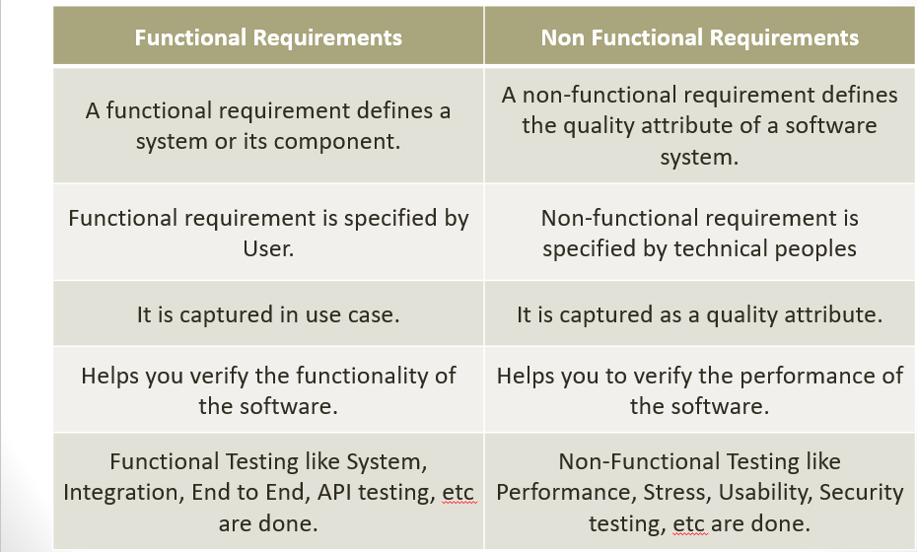
3.Define SRS and give characteristics of good SRS.
ANS:
- SRS is a complete specification and description of requirement of the software that needs to be fulfilled for the successful development of the software system.
- There are two types of Software Requirement Specification:

1.Customer Requirement
2.System Requirement

Characteristics of good SRS:

1.Correct
2.Complete
3.Unambogious
4.Modifiable
5.Verifiable
6.Traceable
7.Consistence

34.Explain activity diagram in brief with example.
ANS:

